2021 Season
Auction draft format.

RK = Rank at the end of the season
Team = Team Name (Team owner)
REC = Record at the end of the season
PF = Points For; number of points the team scored that year. How strong of a team they were offensively.
PA = Points Against; number of points scored against the team that year. How strong or weak their competition was that year.
PF/G = Points For per Game; average number of points scored per game by the team that year
PA/G = Points Against per Game; avg number of points scored against the team per game that year
DIFF = Average point differential that year. + means scored more than opponents, - means scored less than opponents.
MOVES = number of trades, waiver wire acquisitions, player drops or other roster moves.

Final Records & Stats

RK | Team | REC | PF | PA | PF/G | PA/G | DIFF
1 | Sergeant Shultz (John Shultz) | 10-4-0 | 1759.4 | 1641.7 | 125.7 | 117.3 | +8.4
2 | Team Moeter Mouth (jason moe) | 10-4-0 | 1958.6 | 1699.9 | 139.9 | 121.4 | +18.5
3 | Sleepy Rob (Robbie Johnson) | 7-7-0 | 1895.6 | 1820.3 | 135.4 | 130.0 | +5.4
4 | Kupp my Waddles (Kevin Roth) | 8-6-0 | 1710.7 | 1825.4 | 122.2 | 130.4 | -8.2
5 | Team Shooter (Andy Cross) | 9-5-0 | 1718.9 | 1633.9 | 122.8 | 116.7 | +6.1
6 | Silenced By The Lamb (Garrett Hanstead) | 8-6-0 | 1857.4 | 1805.2 | 132.7 | 128.9 | +3.7
7 | Brittle Kittle and McInjury (Joe Rasar) | 7-7-0 | 1723.8 | 1670.5 | 123.1 | 119.3 | +3.8
8 | THE TYREAPER HILL (rey salinas) | 7-7-0 | 1742.8 | 1711.9 | 124.5 | 122.3 | +2.2
9 | Hot Chubb Time Machine (Daniel Oliver) | 5-9-0 | 1584.3 | 1733.5 | 113.2 | 123.8 | -10.7
10 | ... BIG COUNTRY (nick crandall) | 4-10-0 | 1626.0 | 1821.3 | 116.1 | 130.1 | -14.0
11 | UNCLE RICO (Matt Lehman) | 4-10-0 | 1574.3 | 1852.0 | 112.5 | 132.3 | -19.8
12 | Team TrumpBo (Bruce Lehman) | 5-9-0 | 1841.7 | 1777.9 | 131.6 | 127.0 | +4.6

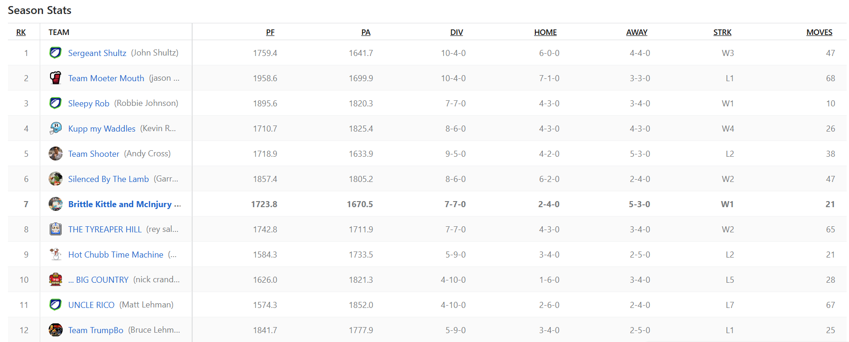

Season Stats
RK | Team
1 | Sergeant Shultz (John Shultz)
2 | Team Moeter Mouth (jason moe)
3 | Sleepy Rob (Robbie Johnson)
4 | Kupp my Waddles (Kevin Roth)
5 | Team Shooter (Andy Cross)
6 | Silenced By The Lamb (Garrett Hanstead)
7 | Brittle Kittle and McInjury (Joe Rasar)
8 | THE TYREAPER HILL (rey salinas)
9 | Hot Chubb Time Machine (Daniel Oliver)
10 | ... BIG COUNTRY (nick crandall)
11 | UNCLE RICO (Matt Lehman)
12 | Team TrumpBo (Bruce Lehman)

PF | PA | DIV | HOME | AWAY | STRK | MOVES
1759.4 | 1641.7 | 10-4-0 | 6-0-0 | 4-4-0 | W3 | 47
1958.6 | 1699.9 | 10-4-0 | 7-1-0 | 3-3-0 | L1 | 68
1895.6 | 1820.3 | 7-7-0 | 4-3-0 | 3-4-0 | W1 | 10
1710.7 | 1825.4 | 8-6-0 | 4-3-0 | 4-3-0 | W4 | 26
1718.9 | 1633.9 | 9-5-0 | 4-2-0 | 5-3-0 | L2 | 38
1857.4 | 1805.2 | 8-6-0 | 6-2-0 | 2-4-0 | W2 | 47
1723.8 | 1670.5 | 7-7-0 | 2-4-0 | 5-3-0 | W1 | 21
1742.8 | 1711.9 | 7-7-0 | 4-3-0 | 3-4-0 | W2 | 65
1584.3 | 1733.5 | 5-9-0 | 3-4-0 | 2-5-0 | L2 | 21
1626.0 | 1821.3 | 4-10-0 | 1-6-0 | 3-4-0 | L5 | 28
1574.3 | 1852.0 | 4-10-0 | 2-6-0 | 2-4-0 | L7 | 67
1841.7 | 1777.9 | 5-9-0 | 3-4-0 | 2-5-0 | L1 | 25

Final Week Scores

Winner's Bracket
- 
- Sergeant Shultz
- (10-4-0, 1st)
- 124.7
- Team Moeter Mouth
- (10-4-0, 2nd)
- 84.8
Box Score
CHAMPIONSHIP MATCHUP

Winner's Consolation Ladder
- 
- Sleepy Rob
- (7-7-0, 3rd)
- 135.5
- Kupp my Waddles
- (8-6-0, 4th)
- 132.5
Box Score
- 
- Silenced By The Lamb
- (8-6-0, 6th)
- 93.4
- 
- Team Shooter
- (9-5-0, 5th)
- 125.0
Box Score

Consolation Ladder
- THE TYREAPER HILL
- (7-7-0, 8th)
- 113.2
- 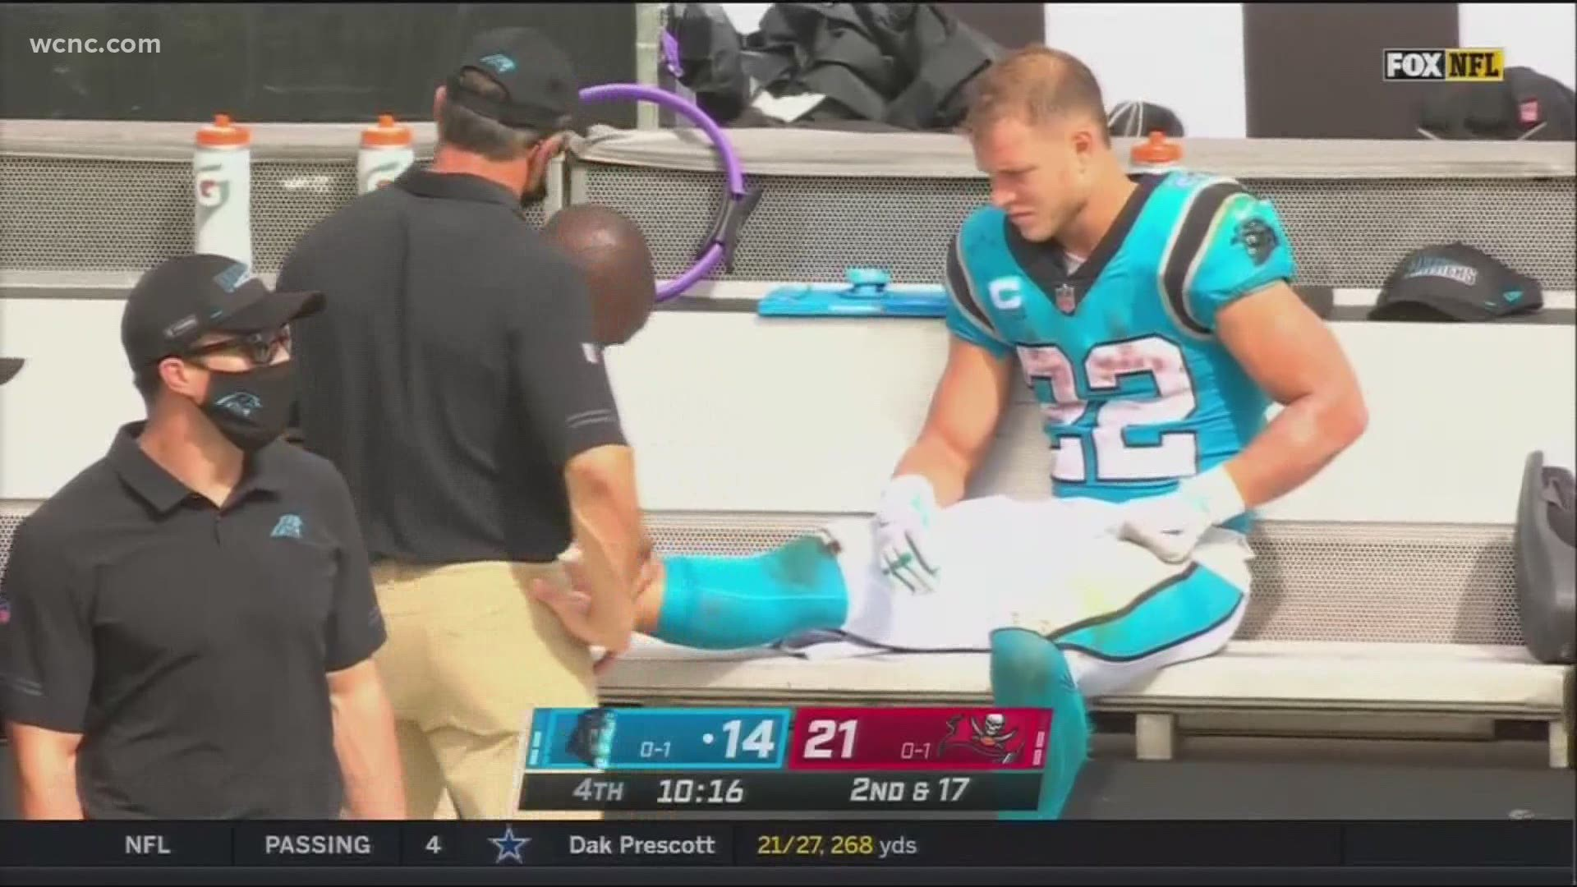
- Brittle Kittle and McInjury
- (7-7-0, 7th)
- 154.4
Box Score
- ... BIG COUNTRY
- (4-10-0, 10th)
- 103.1
- Hot Chubb Time Machine
- (5-9-0, 9th)
- 133.6
Box Score
- 
- UNCLE RICO
- (4-10-0, 11th)
- 86.3
- 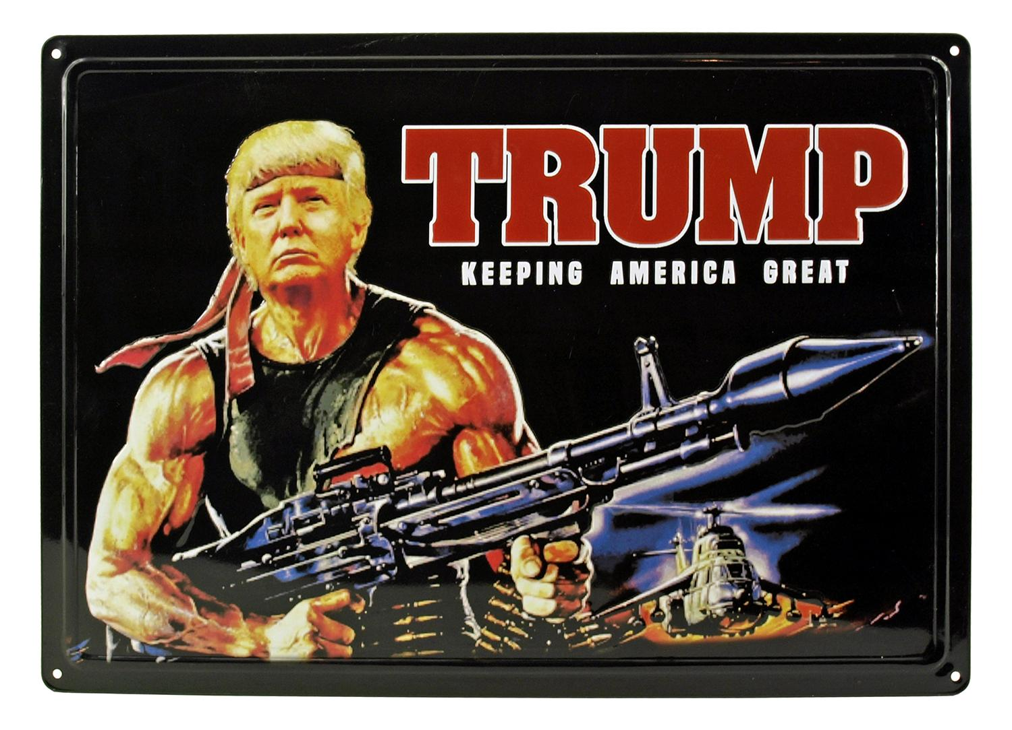
- Team TrumpBo
- (5-9-0, 12th)
- 85.7
Box Score

Draft Results: See the 2021 - DRAFT RESULTS spreadsheet
In an auction draft each team gets $200 to spend on their roster. They can spend as much or little on any player they want as long as they have the budget. Every roster spot must be filled and a player must cost at least $1 or more. Players are randomly selected to be put up for auction and then all teams commence on bidding until the highest amount wins the player for their team. Market conditions, budget, timing, player values, all play huge factors in how a draft can turn out.

Sergeant Shultz (John Shultz)

STARTERS |  | Offseason |  |  | 2021 season
SLOT | Player | %ST | %ROST | +/- | PRK | FPTS | avg | LAST
QB |   Josh Allen  BufQB | 94.6 | 99.9 | 0 | 1 | 418.1 | 24.6 | 23.7
RB | 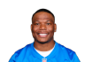  David Montgomery  ChiRB | 87.9 | 98.4 | +0.6 | 21 | 199.0 | 15.3 | 9.9
WR |   A.J. Brown  TenWR | 67.1 | 97.5 | +0.8 | 30 | 189.9 | 14.6 | 16.8
TE |   Travis Kelce  KCTE | 89.2 | 99.9 | 0 | 2 | 271.8 | 17.0 | 13.4
FLEX |   Mike Evans  TBWR | 65.0 | 98.6 | +0.5 | 10 | 268.5 | 16.8 | 26.9
FLEX |   Antonio BrownQ  FAWR | 31.6 | 76.1 | -15.9 | 59 | 131.1 | 18.7 | --
FLEX |   Sony Michel  LARRB | 60.0 | 87.7 | +4.6 | 31 | 153.3 | 9.0 | 5.9
D/ST |   Bills  BufD/ST | 82.9 | 96.7 | +1.6 | 3 | 184.0 | 10.8 | 16.0
K |   Justin Tucker  BalK | 90.7 | 97.9 | +0.2 | 3 | 160.0 | 9.4 | 8.0
 |  |  |  | TOTALS |  | 1975.7 | 136.26 | 120.6
Bench |   James Conner  AriRB | 38.3 | 95.1 | +0.2 | 6 | 258.7 | 17.2 | 27.3
Bench |   Michael GallupQ  DalWR | 22.0 | 69.6 | -6 | 80 | 93.5 | 10.4 | --
Bench |   Saints  NOD/ST | 61.4 | 81.5 | +3.7 | 5 | 172.0 | 10.1 | 15.0
Bench | 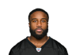  Boston Scott  PhiRB | 6.1 | 24.3 | +2.3 | 59 | 98.6 | 8.2 | --
Bench |   Braxton BerriosQ  NYJWR | 2.1 | 5.6 | +1.3 | 46 | 152.1 | 9.5 | --
 |  |  |  | TOTALS |  | 774.9 | 55.48 | 42.3
IR | 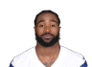  Miles Sanders  PhiRB | 24.9 | 78.0 | -4.6 | 44 | 121.2 | 10.1 | --
IR |   Empty | -- | -- | -- | -- | -- | -- | --

Team Moeter Mouth (jason moe)

STARTERS |  | Offseason |  |  | 2021 season
SLOT | Player | %ST | %ROST | +/- | PRK | FPTS | avg | LAST
QB | 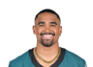  Jalen HurtsQ  PhiQB | 50.9 | 93.7 | -1.9 | 10 | 314.8 | 21.0 | --
RB |   Joe Mixon  CinRB | 69.7 | 97.1 | -2.7 | 4 | 294.9 | 18.4 | --
WR |   Tee Higgins  CinWR | 59.7 | 94.4 | -0.5 | 24 | 227.1 | 16.2 | --
TE |   Foster Moreau  LVTE | 14.3 | 25.3 | +2.1 | 25 | 85.3 | 6.1 | 7.0
FLEX |   Dalvin Cook  MinRB | 84.0 | 99.9 | 0 | 16 | 216.3 | 16.6 | 9.2
FLEX |   Cordarrelle Patterson  AtlRB | 67.7 | 97.2 | -0.9 | 8 | 253.6 | 15.9 | 2.2
FLEX |   Dare Ogunbowale  JaxRB | 12.0 | 28.1 | +4.4 | 83 | 50.1 | 3.9 | 8.5
D/ST |   Colts  IndD/ST | 46.1 | 69.8 | +11.8 | 6 | 170.0 | 10.0 | 0.0
K |   Evan McPherson  CinK | 34.3 | 40.4 | -2.8 | 6 | 147.0 | 9.2 | --
 |  |  |  | TOTALS |  | 1759.1 | 117.26 | 26.9
Bench |   Kareem HuntQ  CleRB | 13.4 | 82.1 | -1.5 | 50 | 110.0 | 13.8 | --
Bench |   AJ DillonQ  GBRB | 28.2 | 83.8 | +0.1 | 23 | 185.6 | 10.9 | 7.7
Bench |   Marquez Valdes-ScantlingQ  GBWR | 6.1 | 20.0 | +0.6 | 82 | 92.0 | 8.4 | 0.0
Bench |   Jaret Patterson  WshRB | 8.7 | 22.4 | +8.9 | 77 | 55.9 | 4.0 | 5.5
Bench |   Tyler Huntley  BalQB | 21.8 | 35.3 | +14.4 | 38 | 82.2 | 11.7 | 6.8
 |  |  |  | TOTALS |  | 525.7 | 48.77 | 20.0
IR |   Darren Waller  LVTE | 31.8 | 95.2 | -0.8 | 17 | 137.5 | 12.5 | 4.2
IR |   Elijah MooreO  NYJWR | 3.1 | 46.1 | -3.3 | 52 | 143.2 | 13.0 | --

Sleepy Rob (Robbie Johnson)

STARTERS |  | Offseason |  |  | 2021 season
SLOT | Player | %ST | %ROST | +/- | PRK | FPTS | avg | LAST
QB |   Justin Herbert  LACQB | 85.3 | 98.5 | +0.2 | 2 | 409.6 | 24.1 | 29.3
RB |   Austin Ekeler  LACRB | 89.9 | 99.8 | +0.1 | 2 | 345.8 | 21.6 | 28.9
WR |   Jarvis Landry  CleWR | 21.0 | 77.0 | +0.2 | 56 | 135.0 | 11.3 | 19.5
TE |   Mark Andrews  BalTE | 97.0 | 99.8 | 0 | 1 | 311.1 | 18.3 | 16.5
FLEX |   DK MetcalfQ  SeaWR | 81.9 | 98.8 | 0 | 16 | 250.3 | 14.7 | 10.8
FLEX | 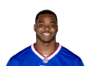  Amari Cooper  DalWR | 73.0 | 97.3 | -0.1 | 27 | 206.5 | 13.8 | 12.9
FLEX |   Deebo Samuel  SFWR | 86.0 | 99.5 | +0.1 | 3 | 358.8 | 22.4 | 28.8
D/ST |   49ers  SFD/ST | 57.2 | 74.0 | -4.6 | 12 | 136.0 | 8.0 | 10.0
K |   Matt Gay  LARK | 81.9 | 89.5 | +0.5 | 4 | 156.0 | 9.2 | 7.0
 |  |  |  | TOTALS |  | 2309.1 | 143.35 | 163.7
Bench |   Tyler Boyd  CinWR | 23.4 | 71.6 | +0.3 | 29 | 191.8 | 12.0 | --
Bench |   Mike Williams  LACWR | 36.0 | 91.8 | +0.5 | 12 | 262.6 | 16.4 | 28.9
Bench |   Joe BurrowQ  CinQB | 32.3 | 84.6 | -2.8 | 6 | 357.2 | 22.3 | --
Bench |   Rashaad Penny  SeaRB | 52.1 | 74.7 | +14.4 | 37 | 133.7 | 13.4 | 30.0
Bench |   Empty | -- | -- | -- | -- | -- | -- | --
 |  |  |  | TOTALS |  | 945.3 | 64.1 | 58.9
IR |   Empty | -- | -- | -- | -- | -- | -- | --
IR |   Empty | -- | -- | -- | -- | -- | -- | --

Kupp my Waddles (Kevin Roth)

STARTERS |  | Offseason |  |  | 2021 season
SLOT | Player | %ST | %ROST | +/- | PRK | FPTS | avg | LAST
QB |   Aaron Rodgers  GBQB | 63.7 | 96.8 | -0.9 | 7 | 342.9 | 21.4 | 14.1
RB | 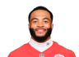  Elijah Mitchell  SFRB | 50.3 | 91.0 | +2 | 26 | 175.0 | 15.9 | 8.5
WR |   Cooper Kupp  LARWR | 95.7 | 99.9 | 0 | 1 | 464.5 | 27.3 | 28.6
TE |   Rob Gronkowski  TBTE | 82.0 | 98.4 | +0.1 | 7 | 177.2 | 14.8 | 22.7
FLEX |   Chase Claypool  PitWR | 33.7 | 85.7 | +0.1 | 37 | 168.6 | 11.2 | 18.0
FLEX |   Odell Beckham Jr.D  LARWR | 42.2 | 90.5 | +0.2 | 57 | 132.1 | 9.4 | 3.8
FLEX |   Jaylen Waddle  MiaWR | 61.3 | 95.2 | +0.2 | 15 | 251.8 | 15.7 | 13.7
D/ST |   Ravens  BalD/ST | 35.2 | 55.7 | -1.2 | 27 | 86.0 | 5.1 | 5.0
K |   Tyler Bass  BufK | 68.3 | 75.5 | +0.5 | 10 | 139.0 | 8.2 | 10.0
 |  |  |  | TOTALS |  | 1937.1 | 129.08 | 124.4
Bench |   Melvin Gordon III  DenRB | 40.1 | 86.6 | -0.5 | 19 | 205.1 | 12.8 | 19.6
Bench | 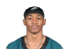  DeVonta Smith  PhiWR | 27.6 | 83.1 | +0.1 | 31 | 189.6 | 11.2 | 7.1
Bench |   Cole Beasley  BufWR | 16.8 | 63.4 | +0.8 | 41 | 161.3 | 10.1 | 7.1
Bench |   Vikings  MinD/ST | 19.5 | 28.9 | +3.5 | 17 | 130.0 | 7.6 | 20.0
Bench |   Kendrick Bourne  NEWR | 3.5 | 21.3 | -0.4 | 33 | 184.5 | 10.9 | 6.2
 |  |  |  | TOTALS |  | 870.5 | 52.55 | 60.0
IR |   Empty | -- | -- | -- | -- | -- | -- | --
IR |   Empty | -- | -- | -- | -- | -- | -- | --

Team Shooter (Andy Cross)

STARTERS |  | Offseason |  |  | 2021 season
SLOT | Player | %ST | %ROST | +/- | PRK | FPTS | avg | LAST
QB |   Dak Prescott  DalQB | 75.5 | 97.4 | -0.4 | 8 | 334.6 | 20.9 | 31.8
RB |   Royce Freeman  HouRB | 1.3 | 5.4 | -0.2 | 97 | 34.6 | 2.9 | 0.0
WR |   Brandin CooksQ  HouWR | 57.9 | 94.3 | +1.2 | 19 | 242.8 | 15.2 | 5.6
TE |   Hunter Henry  NETE | 19.3 | 53.8 | +0.7 | 11 | 164.3 | 10.3 | 13.6
FLEX | 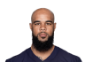  Keenan Allen  LACWR | 88.3 | 99.5 | 0 | 11 | 265.8 | 16.6 | 11.2
FLEX |   Donovan Peoples-Jones  CleWR | 4.3 | 15.6 | -0.2 | 64 | 119.7 | 9.2 | 6.8
FLEX |   Allen Lazard  GBWR | 5.8 | 17.7 | +0.3 | 53 | 142.5 | 10.2 | 24.5
D/ST |   Patriots  NED/ST | 64.1 | 90.3 | -0.1 | 2 | 190.0 | 11.2 | 1.0
K |   Daniel Carlson  LVK | 64.3 | 72.6 | +2.1 | 1 | 168.0 | 9.9 | 21.0
 |  |  |  | TOTALS |  | 1662.3 | 106.3 | 115.5
Bench |   D'Andre Swift  DetRB | 55.3 | 97.3 | -0.1 | 15 | 219.9 | 16.9 | 14.6
Bench |   Van Jefferson  LARWR | 25.7 | 67.2 | -1.3 | 35 | 177.2 | 10.4 | 5.1
Bench | 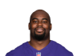  Mike DavisQ  AtlRB | 14.9 | 49.3 | -0.4 | 36 | 138.2 | 8.1 | 1.8
Bench |   Gabriel Davis  BufWR | 4.8 | 19.5 | +2 | 60 | 127.9 | 8.5 | 6.9
Bench |   Jeremy McNichols  TenRB | 1.5 | 8.1 | -0.2 | 66 | 74.6 | 5.7 | --
 |  |  |  | TOTALS |  | 737.8 | 49.73 | 28.4
IR |   Tyler HigbeeQ  LARTE | 30.4 | 70.8 | +1.8 | 14 | 147.0 | 9.8 | 23.5
IR |   Jamaal Williams  DetRB | 9.9 | 60.3 | -1.5 | 45 | 119.8 | 9.2 | 6.2

Silenced By The Lamb (Garrett Hanstead)

STARTERS |  | Offseason |  |  | 2021 season
SLOT | Player | %ST | %ROST | +/- | PRK | FPTS | avg | LAST
QB |   Kyler Murray  AriQB | 81.8 | 99.5 | +0.1 | 11 | 312.2 | 22.3 | 17.1
RB |   Clyde Edwards-Helaire  KCRB | 32.8 | 86.6 | -4.2 | 43 | 121.6 | 12.2 | --
WR |   Diontae Johnson  PitWR | 79.7 | 98.2 | -0.4 | 8 | 284.4 | 17.8 | 12.1
TE |   David Njoku  CleTE | 5.9 | 13.7 | -0.9 | 22 | 112.6 | 7.5 | 3.1
FLEX |   Jonathan Taylor  IndRB | 95.2 | 99.9 | 0 | 1 | 404.1 | 23.8 | 12.5
FLEX |   CeeDee Lamb  DalWR | 87.2 | 99.3 | -0.2 | 20 | 240.8 | 15.1 | 6.5
FLEX |   Javonte Williams  DenRB | 57.6 | 92.4 | -0.4 | 18 | 208.9 | 12.3 | 8.4
D/ST |   Cowboys  DalD/ST | 55.0 | 78.8 | -5.2 | 1 | 213.0 | 12.5 | 5.0
K |   Ryan Succop  TBK | 25.4 | 30.8 | 0 | 13 | 130.0 | 7.6 | 11.0
 |  |  |  | TOTALS |  | 2027.6 | 131.03 | 75.7
Bench |   Brandon Aiyuk  SFWR | 37.7 | 85.5 | -0.3 | 36 | 175.3 | 10.3 | 18.7
Bench |   Darrell Henderson Jr.  LARRB | 20.4 | 76.0 | -5 | 28 | 163.4 | 13.6 | --
Bench |   Cole Kmet  ChiTE | 16.9 | 35.6 | -1.1 | 20 | 121.2 | 7.1 | 8.8
Bench |   Ronald Jones IIQ  TBRB | 38.0 | 77.0 | -11.2 | 65 | 79.2 | 5.3 | --
Bench |   Eagles  PhiD/ST | 32.0 | 49.9 | -11.3 | 18 | 115.0 | 6.8 | -11.0
 |  |  |  | TOTALS |  | 654.1 | 43.1 | 16.5
IR |   Calvin RidleyO  AtlWR | 14.1 | 56.5 | -0.9 | 105 | 71.1 | 14.2 | --
IR |   Kadarius ToneyQ  NYGWR | 1.5 | 22.1 | -0.9 | 92 | 84.2 | 9.4 | --

Brittle Kittle and McInjury (Joe Rasar)

STARTERS |  | Offseason |  |  | 2021 season
SLOT | Player | %ST | %ROST | +/- | PRK | FPTS | avg | LAST
QB |   Patrick Mahomes  KCQB | 88.6 | 99.9 | 0 | 4 | 380.5 | 22.4 | 26.2
RB |   James RobinsonQ  JaxRB | 34.5 | 76.6 | -5.5 | 25 | 175.9 | 12.6 | --
WR | 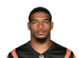  Ja'Marr Chase  CinWR | 71.0 | 98.9 | -0.1 | 5 | 334.6 | 19.7 | 4.6
TE |   George Kittle  SFTE | 92.3 | 99.4 | 0 | 4 | 205.0 | 14.6 | 6.0
FLEX |   Michael Pittman Jr.  IndWR | 49.0 | 92.2 | +0.1 | 17 | 243.6 | 14.3 | 20.4
FLEX |   Darnell Mooney  ChiWR | 41.0 | 78.5 | +3.7 | 23 | 230.7 | 13.6 | 26.6
FLEX |   Devin Singletary  BufRB | 65.3 | 92.1 | +6.8 | 20 | 200.8 | 11.8 | 25.2
D/ST |   Chiefs  KCD/ST | 18.0 | 29.4 | +0.9 | 8 | 154.0 | 9.1 | 10.0
K |   Nick Folk  NEK | 74.9 | 86.6 | +0.4 | 2 | 163.0 | 9.6 | 7.0
 |  |  |  | TOTALS |  | 2088.1 | 127.63 | 126.0
Bench |   Laviska Shenault Jr.  JaxWR | 5.2 | 39.5 | +0.2 | 61 | 127.0 | 7.9 | 11.2
Bench |   Darrel Williams  KCRB | 50.0 | 83.1 | +3.6 | 22 | 198.0 | 11.6 | 7.7
Bench |   K.J. Osborn  MinWR | 12.7 | 37.7 | +0.3 | 39 | 164.5 | 9.7 | 9.1
Bench |   D'Onta Foreman  TenRB | 39.5 | 70.9 | +7.9 | 58 | 99.9 | 11.1 | 9.4
Bench |   Dustin Hopkins  LACK | 4.2 | 5.9 | +0.5 | 10 | 139.0 | 8.2 | 6.0
 |  |  |  | TOTALS |  | 728.4 | 48.54 | 43.4
IR |   Christian McCaffreyQ  CarRB | 15.0 | 50.3 | -0.5 | 40 | 127.5 | 18.2 | --
IR |   Empty | -- | -- | -- | -- | -- | -- | --

THE TYREAPER HILL (rey salinas)

STARTERS |  | Offseason |  |  | 2021 season
SLOT | Player | %ST | %ROST | +/- | PRK | FPTS | avg | LAST
QB |   Taysom HillQ  NOQB | 28.9 | 59.3 | +9.8 | 32 | 126.8 | 10.6 | 10.0
RB |   Chase Edmonds  AriRB | 32.7 | 83.2 | -1.4 | 33 | 145.3 | 12.1 | --
WR |   Davante Adams  GBWR | 87.0 | 99.9 | 0 | 2 | 362.3 | 22.6 | 11.5
TE |   Kyle Pitts  AtlTE | 75.9 | 97.7 | -0.5 | 5 | 182.6 | 10.7 | 2.8
FLEX |   Tyreek Hill  KCWR | 93.9 | 99.9 | 0 | 6 | 306.5 | 18.0 | 1.2
FLEX |   Stefon Diggs  BufWR | 97.2 | 99.9 | 0 | 7 | 289.5 | 17.0 | 23.1
FLEX |   Tony Pollard  DalRB | 18.2 | 67.6 | -3.2 | 24 | 181.6 | 12.1 | --
D/ST |   Dolphins  MiaD/ST | 42.2 | 64.3 | -9.8 | 4 | 173.0 | 10.2 | 22.0
K |   Matt Prater  AriK | 35.3 | 45.6 | +0.2 | 9 | 145.0 | 8.5 | 13.0
 |  |  |  | TOTALS |  | 1912.6 | 121.93 | 83.6
Bench |   Alexander Mattison  MinRB | 12.2 | 72.9 | -8.5 | 38 | 129.9 | 8.1 | 3.1
Bench |   Zach Ertz  AriTE | 50.9 | 82.6 | +4.2 | 6 | 181.7 | 10.7 | 15.4
Bench |   Cam Newton  CarQB | 3.3 | 22.5 | -2.3 | 36 | 85.8 | 10.7 | 0.0
Bench |   Packers  GBD/ST | 37.7 | 59.1 | +1.5 | 15 | 132.0 | 7.8 | -6.0
Bench |   Jeff Wilson Jr.Q  SFRB | 9.2 | 46.1 | -7 | 78 | 53.5 | 6.7 | 0.0
 |  |  |  | TOTALS |  | 582.9 | 43.98 | 12.5
IR |   Damien Harris  NERB | 36.7 | 86.6 | +0.3 | 14 | 223.1 | 14.9 | 17.3
IR |   Jamison CrowderQ  NYJWR | 4.4 | 24.1 | -1 | 67 | 109.7 | 9.1 | 2.6

Hot Chubb Time Machine (Daniel Oliver)

STARTERS |  | Offseason |  |  | 2021 season
SLOT | Player | %ST | %ROST | +/- | PRK | FPTS | avg | LAST
QB |   Matthew Stafford  LARQB | 63.6 | 96.4 | -0.1 | 5 | 360.3 | 21.2 | 17.4
RB |   Najee Harris  PitRB | 97.5 | 99.8 | 0 | 3 | 308.7 | 18.2 | 9.5
WR |   A.J. Green  AriWR | 11.7 | 41.5 | -0.8 | 40 | 161.8 | 10.1 | 6.3
TE |   Dalton Schultz  DalTE | 61.1 | 90.8 | +0.9 | 3 | 208.8 | 12.3 | 17.1
FLEX |   Nick Chubb  CleRB | 90.1 | 99.5 | -0.1 | 11 | 231.3 | 16.5 | 7.0
FLEX |   Christian Kirk  AriWR | 48.4 | 79.0 | +4.6 | 26 | 209.5 | 12.3 | 6.3
FLEX |   Amon-Ra St. Brown  DetWR | 69.9 | 84.5 | +8.6 | 22 | 231.3 | 14.5 | 28.1
D/ST |   Buccaneers  TBD/ST | 86.8 | 97.9 | +0.4 | 7 | 167.0 | 9.8 | 10.0
K |   Graham Gano  NYGK | 42.1 | 54.8 | -0.6 | 19 | 119.0 | 7.0 | 1.0
 |  |  |  | TOTALS |  | 1997.7 | 121.87 | 102.7
Bench |   Russell Wilson  SeaQB | 49.1 | 86.7 | 0 | 15 | 257.7 | 18.4 | 24.9
Bench |   Noah Fant  DenTE | 44.6 | 78.5 | +0.4 | 12 | 159.0 | 9.9 | 2.6
Bench |   Rondale Moore  AriWR | 3.0 | 18.7 | -0.5 | 62 | 121.1 | 8.7 | --
Bench |   Kalif Raymond  DetWR | 0.4 | 2.6 | -0.1 | 51 | 143.4 | 9.0 | 26.4
Bench |   Ty Johnson  NYJRB | 2.7 | 14.5 | -0.4 | 46 | 119.0 | 7.4 | -0.1
 |  |  |  | TOTALS |  | 800.2 | 53.39 | 53.8
IR |   David Johnson  HouRB | 5.0 | 31.8 | -0.9 | 64 | 81.3 | 6.3 | 6.6
IR |   Tevin Coleman  NYJRB | 2.5 | 19.9 | -1.3 | 72 | 61.5 | 5.6 | 0.6

... BIG COUNTRY (nick crandall)

STARTERS |  | Offseason |  |  | 2021 season
SLOT | Player | %ST | %ROST | +/- | PRK | FPTS | avg | LAST
QB |   Trey Lance  SFQB | 7.4 | 20.5 | +0.5 | 40 | 68.6 | 11.4 | --
RB |   Saquon Barkley  NYGRB | 70.2 | 97.2 | -0.3 | 30 | 153.6 | 11.8 | 7.9
WR |   Justin Jefferson  MinWR | 97.5 | 99.8 | 0 | 4 | 348.2 | 20.5 | 25.1
TE |   Mike Gesicki  MiaTE | 44.3 | 88.2 | -0.6 | 10 | 167.0 | 9.8 | 4.2
FLEX |   Alvin Kamara  NORB | 94.3 | 99.9 | 0 | 9 | 243.7 | 18.7 | 20.2
FLEX |   Marquise Brown  BalWR | 53.1 | 94.6 | -0.5 | 21 | 235.3 | 14.7 | 5.7
FLEX |   Michael Carter  NYJRB | 32.5 | 80.2 | +0.4 | 29 | 156.4 | 11.2 | 1.9
D/ST |   Seahawks  SeaD/ST | 19.1 | 32.7 | -2.8 | 21 | 104.0 | 6.1 | 8.0
K |   Mason Crosby  GBK | 39.5 | 52.4 | -0.4 | 15 | 123.0 | 7.2 | 3.0
 |  |  |  | TOTALS |  | 1599.8 | 111.53 | 76.0
Bench | 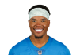  Marvin Jones Jr.  JaxWR | 13.8 | 60.7 | -0.2 | 34 | 182.2 | 10.7 | 21.8
Bench |   Emmanuel Sanders  BufWR | 7.3 | 46.2 | -2 | 58 | 131.7 | 9.4 | --
Bench |   Jakobi Meyers  NEWR | 15.8 | 61.0 | +1.6 | 32 | 186.3 | 11.6 | 9.0
Bench |   Robby Anderson  CarWR | 11.9 | 47.3 | +0.6 | 54 | 141.5 | 8.3 | 18.0
Bench |   Tyler Conklin  MinTE | 18.4 | 40.9 | -0.5 | 16 | 138.3 | 8.1 | 2.6
 |  |  |  | TOTALS |  | 780.0 | 48.23 | 51.4
IR |   Empty | -- | -- | -- | -- | -- | -- | --
IR |   Empty | -- | -- | -- | -- | -- | -- | --

UNCLE RICO (Matt Lehman)

STARTERS |  | Offseason |  |  | 2021 season
SLOT | Player | %ST | %ROST | +/- | PRK | FPTS | avg | LAST
QB |   Empty | -- | -- | -- | -- | -- | -- | --
RB | 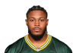  Josh Jacobs  LVRB | 83.6 | 97.9 | +0.3 | 13 | 230.0 | 15.3 | 24.4
WR | 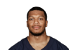  DJ Moore  CarWR | 62.8 | 96.3 | -0.2 | 18 | 243.5 | 14.3 | 17.0
TE |   Dallas Goedert  PhiTE | 47.3 | 87.5 | -3.5 | 9 | 169.0 | 11.3 | --
FLEX |   Aaron Jones  GBRB | 74.0 | 98.8 | -0.6 | 12 | 231.0 | 15.4 | --
FLEX |   Tyler Lockett  SeaWR | 64.2 | 96.9 | -0.1 | 13 | 261.4 | 16.3 | 28.0
FLEX |   DeVante Parker  MiaWR | 23.0 | 70.6 | -1 | 73 | 103.5 | 10.4 | 3.2
D/ST |   Broncos  DenD/ST | 32.9 | 50.0 | -1.7 | 12 | 136.0 | 8.0 | 0.0
K |   Chris Boswell  PitK | 49.1 | 55.0 | +0.1 | 4 | 156.0 | 9.2 | 11.0
 |  |  |  | TOTALS |  | 1530.4 | 100.19 | 83.6
Bench |   Terry McLaurin  WshWR | 62.2 | 97.0 | -0.1 | 25 | 222.5 | 13.1 | 13.3
Bench |   Myles Gaskin  MiaRB | 24.0 | 82.4 | -3.1 | 27 | 174.6 | 10.3 | 4.0
Bench |   Lamar Jackson  BalQB | 30.0 | 93.9 | -3.7 | 16 | 252.1 | 21.0 | --
Bench |   Pat Freiermuth  PitTE | 24.7 | 59.4 | +2.5 | 13 | 151.7 | 9.5 | 11.3
Bench |   Justin Fields  ChiQB | 3.2 | 19.9 | -0.6 | 31 | 131.8 | 11.0 | --
Bench |   Josh Reynolds  DetWR | 0.6 | 3.8 | -0.3 | 98 | 80.6 | 8.1 | 2.1
 |  |  |  | TOTALS |  | 1013.3 | 72.89 | 30.7
IR |   Empty | -- | -- | -- | -- | -- | -- | --
IR |   Empty | -- | -- | -- | -- | -- | -- | --

Team TrumpBo (Bruce Lehman)

STARTERS |  | Offseason |  |  | 2021 season
SLOT | Player | %ST | %ROST | +/- | PRK | FPTS | avg | LAST
QB |   Tom Brady  TBQB | 83.8 | 99.2 | 0 | 3 | 409.5 | 24.1 | 27.0
RB |   Ezekiel ElliottQ  DalRB | 87.3 | 99.3 | -0.3 | 7 | 255.9 | 15.1 | 10.0
WR |   Hunter Renfrow  LVWR | 73.6 | 92.6 | +0.4 | 9 | 271.1 | 15.9 | 17.9
TE |   Dawson Knox  BufTE | 59.7 | 89.3 | -0.7 | 8 | 169.1 | 11.3 | 8.3
FLEX |   Antonio Gibson  WshRB | 62.9 | 96.7 | -0.5 | 10 | 236.1 | 14.8 | 24.1
FLEX | 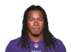  Devonta Freeman  BalRB | 32.3 | 71.4 | +0.1 | 32 | 146.6 | 9.2 | 4.7
FLEX |   Russell Gage  AtlWR | 24.0 | 59.3 | -1.1 | 38 | 168.0 | 12.9 | 29.6
D/ST |   Cardinals  AriD/ST | 34.7 | 65.7 | -3.5 | 9 | 153.0 | 9.0 | 7.0
K |   Harrison Butker  KCK | 52.4 | 76.1 | +2.6 | 12 | 135.0 | 8.4 | 10.0
 |  |  |  | TOTALS |  | 1944.3 | 120.64 | 138.6
Bench |   J.D. McKissicQ  WshRB | 2.8 | 33.8 | -1.3 | 39 | 127.9 | 11.6 | --
Bench |   Leonard Fournette  TBRB | 19.7 | 78.5 | -3.5 | 5 | 260.6 | 18.6 | --
Bench |   Sterling ShepardQ  NYGWR | 3.1 | 28.3 | -1 | 99 | 79.7 | 11.4 | --
Bench | 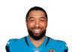  Tim Patrick  DenWR | 2.3 | 15.2 | -0.6 | 42 | 157.4 | 9.8 | 15.5
Bench | 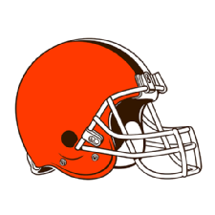  Browns  CleD/ST | 24.9 | 39.6 | +0.5 | 18 | 115.0 | 6.8 | 9.0
 |  |  |  | TOTALS |  | 740.6 | 58.23 | 24.5
IR | 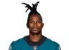  Julio Jones  TenWR | 16.6 | 64.4 | -1.6 | 95 | 82.4 | 8.2 | 16.8
IR |   Empty | -- | -- | -- | -- | -- | -- | --

